Tenda MW6-Set up Nova for the first time, APP can’t detect Nova, what should I do?

You buy a new Nova, when you set up it for the first time. Open Tenda Wi-Fi APP, it pops a window that shows “Connect to the Wi-Fi network of a Tenda device”, Please refer below solutions to solve this problem;
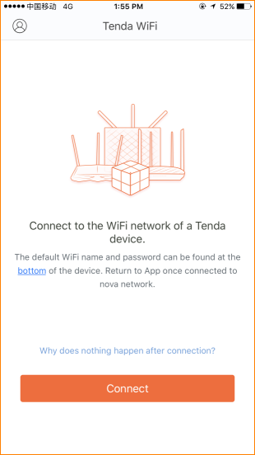

- Please confirm broadband cable connect to the wan port of first Nova;
- Please power on the first Nova, when it connect network well, then power on the second Nova;
- Mobile phone need to connect Nova Wi-Fi signal, if you connect other Wi-Fi signal, please reconnect Nova Wi-Fi signal;
- Power off Nova and power on again, close Tenda Wi-Fi APP and open it again, check whether APP can detect new Nova now;

